Treatment 1

The market institution is a posted offer market; the Seller is liable to pay a tax on each unit sold; and the tax is salient for both Sellers and Buyers.

Today’s experiment:

This is an experiment in the economics of decision making in markets.

Your earnings will be determined by your own decisions and the decisions of others as described in the following instructions. SO IT IS IMPORTANT THAT YOU READ THESE INSTRUCTIONS CAREFULLY. This experiment is structured so that only you know your earnings. All of the money that you earn will be paid to you privately IN CASH immediately following the end of today’s experiment.

Scenario

You will be randomly assigned to the role of a Buyer or a Seller. As such, you will decide the number of units of a fictitious commodity that you would like to buy or sell. You will keep the same role for the entire experiment.

Anonymity

Your role and the role of others will be kept private. You will not know anyone’s role other than your own.

Trading screens

Sellers post offers to sell and Buyers accept offers through a series of action screens. We explain below how Sellers interact with these screens to post Offers to sell in the market.

Seller’s instructions:

You are a Seller. Sellers in the market can post Offers to sell units of a fictitious commodity to Buyers in the market. During each round of today’s experiment, you are given an opportunity to Offer one or more units of a fictitious commodity to the market. You are also given an opportunity to set the price at which you are willing to sell the specified number of units.

A tax per unit is collected from the Sellers in the market. The amount of the unit tax is $12.00.

There will be several Sellers and Buyers in the market.

How does a Seller like yourself make money in today’s experiment?

Sellers make money in today’s experiment by selling units at prices greater than their costs plus tax per unit. The Seller’s cost per unit is provided on a screen, as described below. A Seller’s unit cost information is private and will be revealed only to the Seller. A Seller’s profit from trading a unit is computed by subtracting the Seller’s cost for that unit and the unit tax from the purchase price.

How does a Buyer make money in today’s experiment?

Buyers make money in today’s experiment by buying units at prices lower than the Buyer’s values per unit. A Buyer’s profit from buying a unit is computed by subtracting the purchase price from the Buyer’s value for that unit.

How does a Seller like yourself trade in the market?

Below we explain how a Seller interacts with the trading screen to post an Offer to the market. The Sellers post their Offers to the market simultaneously, and this period of the experiment is called the posting period. The posting period lasts two and one-half minutes. There will be many rounds of the experiment and thus many opportunities to post Offers to the market.

The numbers used in the example below are for instructional purposes only and may not be the same numbers you will see during the experiment.

Seller’s Figure 1

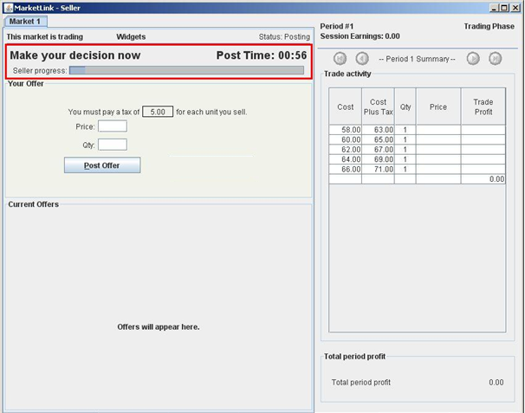
.

Time Remaining to Post an Offer

During each round of today’s experiment, Sellers are given an opportunity to post Offers to the market. Sellers are given two and one-half minutes to complete this task. The highlighted area of the trading screen in Figure 1 above displays the status of the experiment and the time remaining for the Sellers to complete their decisions.

Seller’s Figure 2

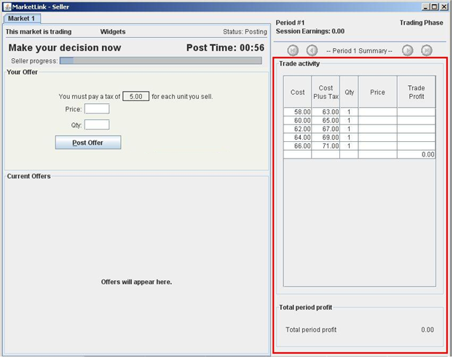
.
Selling in the market

The highlighted area of the screen in Figure 2 above provides information on the Seller’s costs and tax per unit. A Seller should consider this information before posting an Offer to the market. An Offer consists of a price and quantity, or, in other words, the number of units that a Seller is willing and able to sell at a given price of the Seller’s choosing.

In deciding what price and quantity to post to the market, you should always check the cost to you of selling the last unit that you post to sell. The cost to you of each unit is given by the numbers in the Cost Plus Tax column.

The Seller may Offer to sell as many units as they have available to sell. The column labeled “Qty” in the highlighted area of the screen indicates that the Seller may Offer to sell up to five units.

Seller’s Figure 3

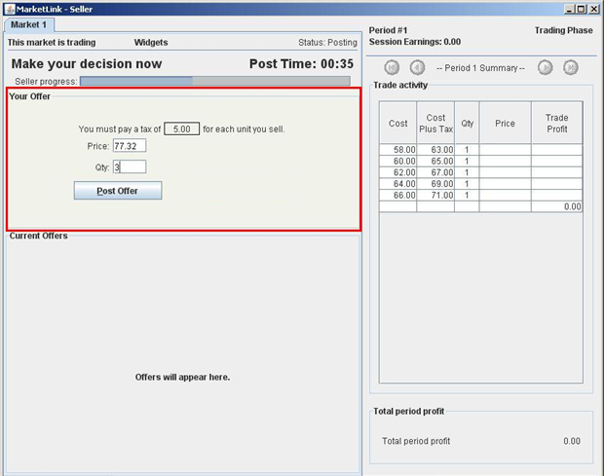
.
Submitting an Offer to the market

A Seller posts Offers to the market in the highlighted area of the screen in Figure 3 above. The Offer price is entered in the box labeled “Price” in dollars and cents. For example, 77.32 indicates an Offer price of 77 dollars and 32 cents.

A Seller can post any price greater than $0 but less than $100.

The quantity is entered in the box labeled “Qty” and must be a whole number. For example, 3 indicates an Offer to sell 3 units. The posted quantity is the maximum number of units the Seller is willing to sell at the posted offer price. As previously explained, the Seller may offer to sell as many units as they have available to sell.

The Seller posts an Offer to the market by clicking on the “Post Offer” button on the trading screen. Be aware that once the Offer is posted to the market, it cannot be retrieved or recalled. Consider your decisions carefully before clicking on the “Post Offer” button. Note that in this example there is a 5.00 dollar tax per unit which is collected from the Seller.
Seller’s Figure 4

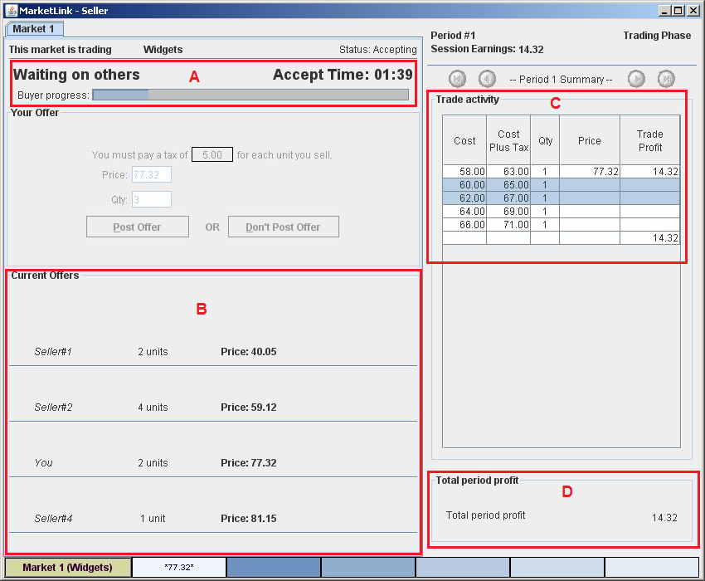

Market Information: Knowing where you stand in the market

Once all Sellers have submitted their offers, Buyers will take turns accepting offers. The screen in Figure 4 above shows the sort of information that will be provided to you while buyers are making their decisions. Note that a buyer bought one unit of your offer. You made profit of 14.32 dollars, and you still have an offer to sell two additional units at a price of $77.32 in the market.

- The progress bar in the highlighted area of the trading screen labeled A in Figure 4 above displays the amount of time remaining for Buyers to buy in this period.
- The highlighted area labeled B displays your own Offer which is labeled You.
- The highlighted area labeled C displays your profit on each unit sold as well as the total period profit.
- The highlighted area labeled D displays your total period profit for the period or round just completed.

Questionnaire and payment

After you have finished all of your decisions in today’s experiment, you will complete a brief on-line questionnaire. We will convert your total earnings in experimental dollars into U.S. dollars at the exchange rate announced at the beginning of today’s experiment. The more experimental dollars you earn, the more U.S. dollars you will be paid at the end of today’s experiment. You will receive payment of your earnings, and the experiment is over.

Today’s experiment:

This is an experiment in the economics of decision making in markets.

Your earnings will be determined by your own decisions and the decisions of others as described in the following instructions. SO IT IS IMPORTANT THAT YOU READ THESE INSTRUCTIONS CAREFULLY. This experiment is structured so that only you know your earnings. All of the money that you earn will be paid to you privately IN CASH immediately following the end of today’s experiment.

Scenario

You will be randomly assigned to the role of a Buyer or a Seller. As such, you will decide the number of units of a fictitious commodity that you would like to buy or sell. You will keep the same role for the entire experiment.

Anonymity

Your role and the role of others will be kept private. You will not know anyone’s role other than your own.

Trading screens

Sellers post offers to sell and Buyers accept offers through a series of action screens. We explain below how Buyers interact with these screens to accept Offers posted to the market by Sellers.
Buyer’s instructions:

You are a Buyer. Buyers are given an opportunity to purchase units of a fictitious commodity from Sellers in the market, by accepting Offers posted by Sellers

A tax per unit is collected from the Sellers in the market. The amount of the unit tax is $12.00.

There will be several Buyers and several Sellers in the market.

How does a Buyer like yourself make money in today’s experiment?

Buyers make money in today’s experiment by purchasing units at prices lower than the Buyer’s values per unit. The Buyer’s values for units are provided on a trading screen, as described below. A Buyer’s unit value information is private and will be revealed only to the Buyer. A Buyer’s profit from buying a unit is computed by subtracting the purchase price from the Buyer’s value for the unit.

How does a Seller make money in today’s experiment?

Sellers make money in today’s experiment by selling units at prices greater than their costs plus tax per unit. A Seller’s profit from selling a unit is computed by subtracting the Seller’s cost for that unit and the unit tax from the purchase price.

How does a Buyer like yourself trade in the market?

Below we explain how a Buyer interacts with the trading screen to accept Offers from the market. The Buyers take turns accepting offers from the market, and this phase of the experiment is called the accepting phase. There will be many rounds of the experiment and thus many opportunities to accept Offers from the market.

The numbers used in the example below are for instructional purposes only and may not be the same numbers you will see during the experiment.

Buyer’s Figure 1

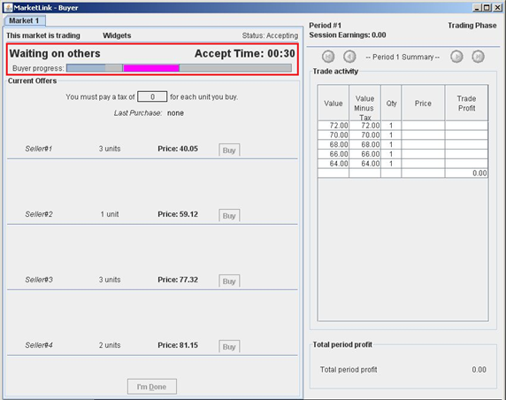

Time Remaining to Accept Offers:
During each round of today’s experiment, Buyers are given an opportunity to accept offers available in the market. Each Buyer enters the market in a randomly assigned sequence. When a Buyer’s turn arrives, the Buyer, and only that Buyer, may accept Offers in the market. Each Buyer is given the same amount of time to complete their decisions. The highlighted area of the trading screen in Figure 1 above displays the status of the experiment. The pink area graphically represents when it is your turn and the time remaining for you to accept offers. Once the progress bar reaches the pink area, it is your turn to accept offers. In this example, some other Buyer has 30 seconds remaining to complete her (his) decisions.

Buyer’s Figure 2

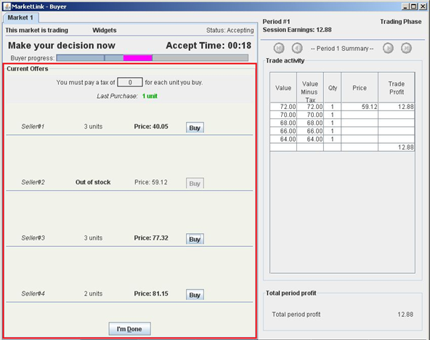

Buying in the market BY ACCEPTING AN OFFER

The highlighted area of the screen in Figure 2 above is the Buyer’s action screen. The highlighted area shows the number of units available for sale and the Offer price of each Seller in the market.

When it is your turn to accept offers, you can accept a Seller’s Offer by clicking the “Buy” button next to the respective Seller’s quantity and price information. You will buy 1 unit each time you click the Buy button, as long as the respective Seller still has units available to sell. Note that in this example, you bought one unit at a price of 59.12 dollars and made a profit of 12.88 dollars.

Buyer’s Figure 3

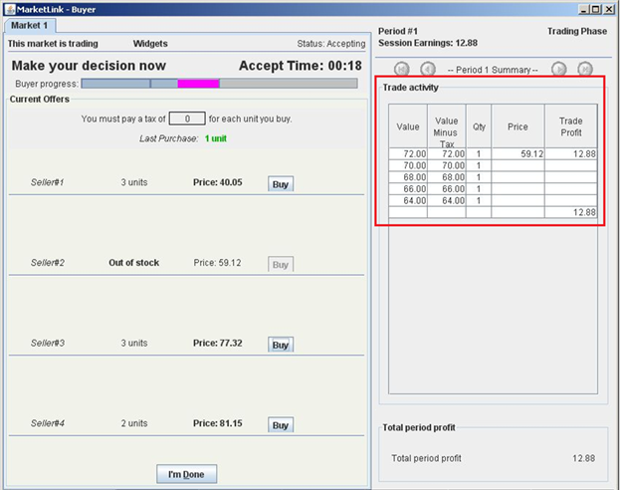

Making money in this experiment

The highlighted area of the trading screen in Figure 3 above provides information on the Buyer’s values per unit. A Buyer should consider this information before accepting an Offer in the market.

In deciding whether to accept an Offer available in the market, you should always check the Value to you of the next unit. The Value to you is given by the number in the Value column in the first row that does NOT contain an entry for Trade Profit.

The rightmost column is the “Trade Profit” column that shows the profit or loss that you made on each unit that you buy in the market.

When you have completed your decisions, you may click on the “I’m Done” button at the bottom of the screen.
Buyer’s Figure 4

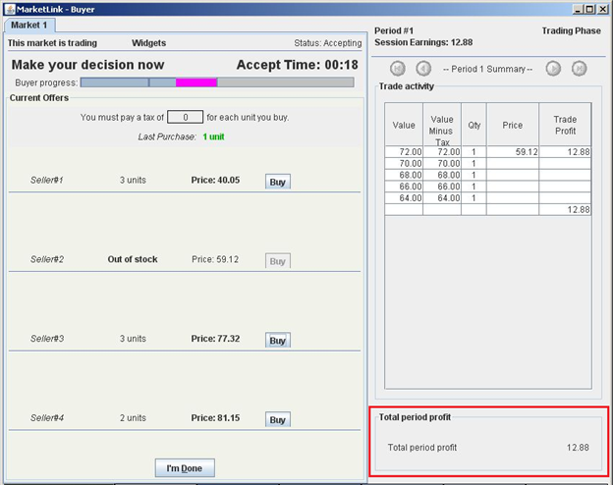

Market Information: Knowing where you stand in the market

The highlighted area of the trading screen in Figure 4 above indicates the total period profit (loss).
Questionnaire and payment

After you have finished all of your decisions in today’s experiment, you will complete a brief on-line questionnaire. We will convert your total earnings in experimental dollars into U.S. dollars at the exchange rate announced at the beginning of today’s experiment. The more experimental dollars you earn, the more U.S. dollars you will be paid at the end of today’s experiment. You will receive payment of your earnings, and the experiment is over.

